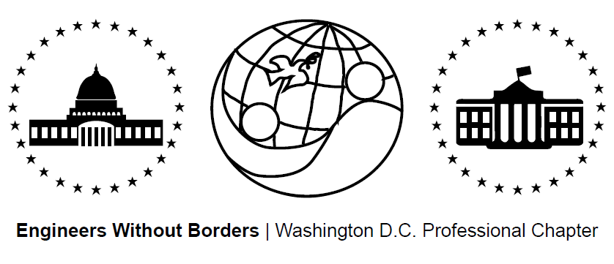
www.ewb-dc.org
General Chapter Meeting – Thursday, August 21st, 2014
George Washington University – Hall of Government - Room 101
(710 21st Street N.W., Washington, DC)

- Introductions and EWB in a Nutshell – Jonathan Mead < president@ewb-dc.org>
- EWB National/Regional News – Ben Hsu <vice_president@ewb-dc.org>
Design Global; Engineer Local
- EWB-USA international accredited course & conference
- Dates: Oct. 5-11, 2014 Location: Panama
- Registration ($1,500): http://panama2014.org/
EWB-USA National Conference
- Hosted by EWB-DC, EWB-Montgomery College, and EWB-Frederick MD
- Dates: Oct 31. – Nov. 2 Location: Reston, VA
- Link: http://ewbusaconference.org/
Solar Symposium 2014
- “Using Solar Energy to Generate Wealth in Lower Income Communities”
- Date: Tuesday September 23rd, 2014 Location: George Washington U.
- Link: http://solar.gwu.edu/events/2014-solar-symposium
Bridge Builder Conference
- Hands on workshops in development infrastructure construction
- Panel discussions with bridge builders and global change agents
- Dates: Sept 12-14, 2014 Location: Winter Park, CO
- Registration ($150): bridgestoprosperity.org
EWB-USA Fall Grant Cycle
- All projects should apply! Cycle opens Sept. 2nd with an October 2nd deadline
New Chapter: EWB - Northern Virginia
- The new Northern Virginia Chapter has launched!
- Contact Janet Chang to get involved: jjchang@bechtel.com
Become an EWB Member!
- Get access to a great suite of online technical resources
- Vote / run in chapter elections, travel on project trips, help fund EWB-DC projects
- EWB-DC Updates – Ben Hsu <vice_president@ewb-dc.org>
Gala Planning
- Proposed Dates: Late January 2015
- Status: Venue selected, strategizing financial success plan
Chapter Hike & Picnic in Shenandoah
- August 9th hike had gorgeous weather, fun rock scrambling, and fantastic views!
- Panama Project Updates - Rahul, Nina, Mohamed <panama@ewb-dc.org>
- Preliminary community technology center design and calculations progressing with hope to have them ready in the next two - three months
- Next meeting: Wednesday, Sept 3 @ 7pm - MLK Jr. Memorial Library
- Cameroon Project Updates - Rachel & Ashley <cameroon@ewb-dc.org>
- Spring/gravity water supply design wrapping up for mid-September final submission
- Next trip to the community planned for December 2014
- Next meeting: Thursday, Aug 28 @ 7:00PM
- El Salvador Project Updates - Angeline <santaclara@ewb-dc.org>
- Phase II of design - looking for a low-cost, two-burner, fuel-efficient design
- Next trip to the community in the fall will demonstrate stove options to community for input towards final designs / configurations
- Next Meeting: TBD
- Fundraising Update:
- Panama Project: DC United vs. Philadelphia Union Game
  - September 27th: 12:00pm Tailgate Party - 3pm Game
  - Order Tickets from Nina (panama@ewb-dc.org): $25
- Shop Amazon Smile and support EWB (smile.amazon.com)
- T-shirt Fundraiser: http://tinyurl.com/ewb-dc-tshirt
- Treasurer’s Report - Marie <treasurer@ewb-dc.org>
- August 15th update: Total current funds = $36,420.54
    - Chapter (unrestricted) = $8,181.70
    - El Salvador = $6,953.94
    - Cameroon = $20,933.46
    - Panama = $351.44
- Local Student Chapter Updates
- Officer Elections: Candidate Nominations
- Positions: President, VP, Treasurer, Secretary
- Voting Eligibility: All dues paying EWB-DC members of greater than 6 months
- Nomination period: August 21-29 (Email: president@ewb-dc.org)
- Elections held online from September 3-12, 2014
- New officers announced at the September 16th chapter meeting
- New officer term begins October 1, 2014
- Future Meeting Dates for 2014 – Note all meetings are at 7:00pm
- September 16th (Tuesday) @ George Washington University – Phillips Hall, Rm 415
- October 15th (Wednesday) @ George Washington University – Monroe Hall, Rm 110
- November 20th (Thursday) @ George Washington University – Funger Hall, Rm 222
- December 17th (Wednesday) @ George Washington University – Blding/Room TBA

