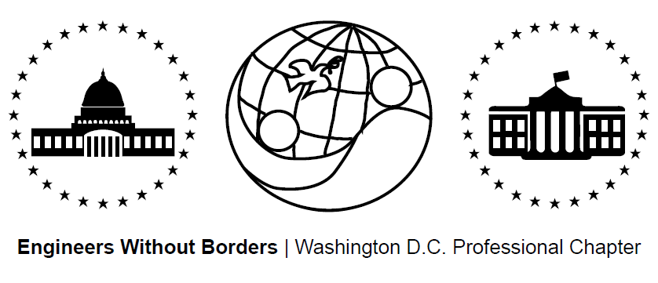
www.ewb-dc.org
General Chapter Meeting – Wednesday, January 21, 2015
George Washington University – Hall of Government – Room 101
(710 21st Street, N.W., Washington, DC)

- Introductions and EWB in a Nutshell – Jonathan Mead < president@ewb-dc.org>
- EWB National / Regional News – Ben Hsu <vice_president@ewb-dc.org>
EWB-USA National Conference Presentations Now Available
- Link: http://ewbusaconference.org/category/latest-news/
New EWB-USA Report Templates
- Use of updated templates now required as of Jan 1. (get templates from the web!)
New Assessment Trip Webinars
- Will be required for all first project assessment trips in 2015
Development Engineering Courses / Conferences in Mexico
- Hosted by CATIS-Mexico: http://www.catis-mexico.org/
- “Analysing Earth Friendly Technologies: Studying Context, Culture and Design”
- Dates: July 4 – 18, 2015 and July 25 – August 8, 2015
New Chapter: EWB - Northern Virginia
- Currently launching an international as well as a domestic project
- Link: http://www.ewb-nova.org/ Contact Janet Chang: jjchang@bechtel.com
- Chapter Meeting: Tuesday, Jan. 27, 2015: 7-8:30PM at Virginia Tech NoVa Center
Become an EWB Member!
- Get access to a great suite of online technical resources
- Vote / run in chapter elections, travel on project trips, help fund EWB-DC projects
- EWB-DC Updates – Ben Hsu <vice_president@ewb-dc.org>
Gala Planning
- Date: March 6, 2015 Venue: Top of the Town, in Rosslyn
- To assist with planning please email: president@ewb-dc.org
Chapter Year End Report Writing
- Please let Jonathan know if interested in contributing: president@ewb-dc.org
Student STEM Conference Presenters Wanted
- 3rd Annual UnCommon Alliance STEM Conference at Georgetown Day School
- Keynote speaker: Megan Smith - US Chief Technology Officer in the Office of Science and Technology Policy and former Vice President of Google
- Please let Jonathan know if interested in volunteering: president@ewb-dc.org
- Panama Project Updates - Rahul, Nina, Ross <panama@ewb-dc.org>
- Assessment Trip II completed: Oct. 10th – 19th, 2014
- Alternative analyses and design underway for alt. energy tech center / library
- Next meeting: Thursday February 5th @ 7:00PM, MLK Library- Digital Commons 2
- Cameroon Project Updates - Rachel & Ashley <cameroon@ewb-dc.org>
- Spring/gravity water supply design submitted
- Next trip to the community planned for January 2015
- Next meeting: Tuesday, February 3rd, 2015 @ 7:00PM at George Washington University – Phillips Hall in Room 108 (801 22nd Street NW, Washington DC)

- El Salvador Project Updates - Angeline <santaclara@ewb-dc.org>
- Phase II of design - looking for a low-cost, two-burner, fuel-efficient design
- Next trip will demonstrate stove options to community for input towards final designs
- Next Meeting: January 26, 2015 @ 6:30PM at MLK Library Digital Commons 2
- Fundraising Updates:
Eats Place Restaurant Takeover: Cameroon Fundraiser on February 16th -Presidents’s Day
- Guest chef Edgar Steele & Cameroon team host 2 dinner seating + art / craft auction
- Tickets: http://www.eventbrite.com/e/eatsplace-ewb-dc-cameroon-dinner-fundraiser-tickets-15406636665?aff=es2&rank=2
- Or search “Cameroon” at Eventbrite.com !
Amazon.com Fundraising: 6% to EWB-DC! - Link: http://www.amazon.com/?tag=ewbdc-20
- Treasurer’s Report - Nicole <treasurer@ewb-dc.org>
- Total current funds = $59,942.39
    - Chapter (unrestricted) = $6,076.82 El Salvador = $5,868.94
    - Cameroon = $47,455.54 Panama = $541.09
- Local Student Chapter Updates
- EWB-Hartford Sabhung, Nepal Solar Water Supply Video Showing
- Future Chapter Meeting Dates – Note meetings are at 7:00pm
- February 18th (Wednesday) @ George Washington University – Duques Hall Room 360 (2201 G St NW, Washington DC)
- March 18th (Wednesday) @ George Washington University – Phillips Hall Room 108
(801 22nd St NW, Washington DC)
- April 15th (Wednesday) @ George Washington University – Phillips Hall Room 108
(801 22nd St NW, Washington DC)
- May 20th (Wednesday) @ George Washington U. – Building / Room TBD

