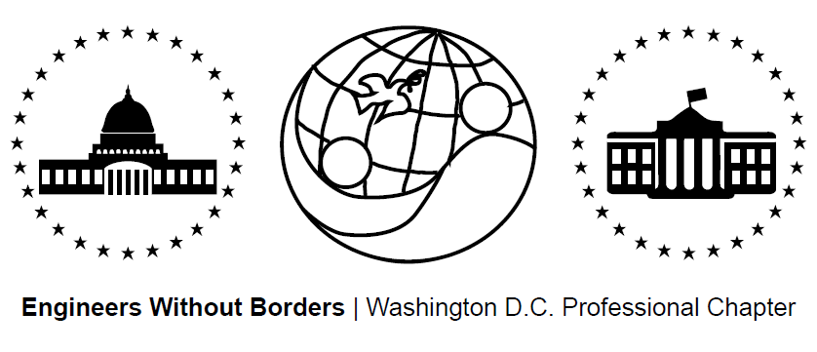
www.ewb-dc.org
General Chapter Meeting – Tuesday, September 16th, 2014
George Washington University – Phillips Hall - Room 415
(801 22nd Street NW, Washington, DC)

- Introductions and EWB in a Nutshell – Jonathan Mead < president@ewb-dc.org>
- EWB National/Regional News – Ben Hsu <vice_president@ewb-dc.org>
Design Global; Engineer Local
- EWB-USA international accredited course & conference
- Dates: Oct. 5-11, 2014 Location: Panama
- Registration ($1,500): http://panama2014.org/
EWB-USA National Conference
- Hosted by EWB-DC, EWB-Montgomery College, and EWB-Frederick MD
- Dates: Oct 31. – Nov. 2 Location: Reston, VA
- Link: http://ewbusaconference.org/ ½ price for volunteers: Email JM by 9/17
Solar Symposium 2014
- “Using Solar Energy to Generate Wealth in Lower Income Communities”
- Date: Tuesday September 23rd, 2014 Location: George Washington U.
- Link: http://solar.gwu.edu/events/2014-solar-symposium
CATIS Mexico – Compressed Earth Block & Natural Plasters Workshop
- Dates: November 13-15, 2014 Location: San Miguel de Allende, Mexico
- Link: http://catis-mexico.org/ Price: $300
EWB-USA Fall Grant Cycle
- All projects should apply! The deadline is October 2nd.
New Chapter: EWB - Northern Virginia
- The new Northern Virginia Chapter has launched!
- Kick-off / general body meeting: Tuesday, Sept. 23rd @ 7:00pm
- Location: Virginia Tech/NVC Facility Room 221: 7054 Haycock Rd, Falls Church, VA
- Domestic project collaboration opportunity:
  - Keya Wakpala Waicageyapi Community House for Rosebud Sioux Tribe SD
  - Link: https://s3.amazonaws.com/ewbgeneral/Open%20Projects8_7_14.pdf
- Contact Janet Chang to get involved: jjchang@bechtel.com
Become an EWB Member!
- Get access to a great suite of online technical resources
- Vote / run in chapter elections, travel on project trips, help fund EWB-DC projects

- EWB-DC Updates – Ben Hsu <vice_president@ewb-dc.org>
Gala Planning
- Proposed Dates: December / January 2014/2015
- Status: Searching smaller venue for ~65 people, ideas welcome
- Please email Eric Rumpf with ideas or to get involved: RumpfEN@state.gov
Construction Training #2: Concrete Work
- Date: Saturday, October 18th
- Location: Metro accessible construction facility in Alexandria
- RSVP to Cameroon@ewb-dc.org by October 8th
First Aid / CPR Training
- Date: Saturday, September 27th, 2014 Cost: $45
- Location: The Rockville campus of Montgomery College, room SC412
- RSVP to Craig Mogren (craig.mogren@montgomerycollege.edu) a.s.a.p.
- Details: The instructor is Barry Collier, a retired police officer and academy trainer. He is certified to teach all levels of first aid, including wilderness first aid.
Officer Elections
- New/old officers are: Jonathan Mead, Ben Hsu, Marie Hoffman, & Shane Trexler
- Recruiting new treasurer; Marie is happy to provide training / assistance
- Panama Project Updates - Rahul, Nina, Mohamed <panama@ewb-dc.org>
- Upcoming Assessment II trip Oct. 10th – 19th, 2014: fundraising push underway
- Next meeting: October 2nd at MLK Library @ 7:00pm
- Cameroon Project Updates - Rachel & Ashley <cameroon@ewb-dc.org>
- Spring/gravity water supply design submitted 9/14!
- Next trip to the community planned for December 2014
- Next meeting: Thursday, Oct. 9th @ 7:00PM at GWU Monroe Hall - Room 350
- El Salvador Project Updates - Angeline <santaclara@ewb-dc.org>
- Phase II of design - looking for a low-cost, two-burner, fuel-efficient design
- Next trip will demonstrate stove options to community for input towards final designs
- Next Meeting: TBD
- Fundraising Updates:
Happy Hour – Guest Bartend @ Thomas Foolery
- Date: Thursday Sept. 25th, 2014 Address: 2029 P St NW, Washington, DC
DC United vs. Philadelphia Union Game
- Date: Saturday Sept. 27th, 2014 (12:00pm Tailgate Party - 3pm Game)
- Location: RFK Stadium Price: $25
- Order tickets from Nina (panama@ewb-dc.org)
EWB-DC T-Shirt Fundraiser - Link: http://tinyurl.com/ewb-dc-tshirt
Amazon.com Fundraising: 5% to EWB-DC! - Link: http://www.amazon.com/?tag=ewbdc-20
- Treasurer’s Report - Marie <treasurer@ewb-dc.org>
- Total current funds = $36,420.54
    - Chapter (unrestricted) = $8,181.70 El Salvador = $6,953.94
    - Cameroon = $20,933.46 Panama = $351.44
- Local Student Chapter Updates
  - EWB-GWU
    - Meeting 10/1/2014 9:00pm – EWB-DC to share on professional perspective
    - Ben Hsu to travel as mentor on GWU next assessment trip
    - Grace Richardson will join Ben as a second mentor for GWU
- Future Meeting Dates for 2014 – Note all meetings are at 7:00pm
- October 15th (Wednesday) @ George Washington University – Monroe Hall, Rm 110
- November 20th (Thursday) @ George Washington University – Funger Hall, Rm 222
- December 17th (Wednesday) @ George Washington University – Blding/Room TBA

