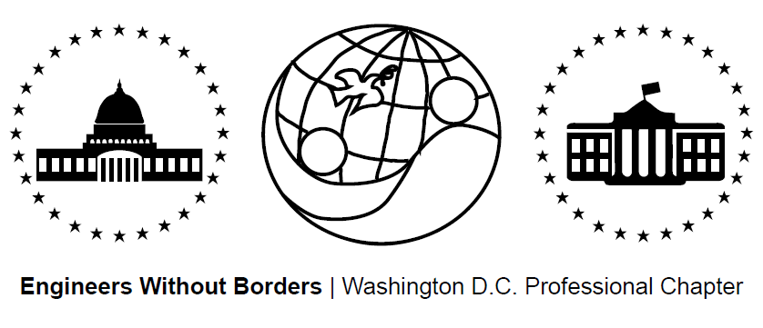
www.ewb-dc.org
General Chapter Meeting – Wednesday, December 15th, 2014
George Washington University – Monroe Hall - Room 110
(2115 G Street NW, Washington, DC)

- Introductions and EWB in a Nutshell – Jonathan Mead < president@ewb-dc.org>
- EWB National / Regional News – Ben Hsu <vice_president@ewb-dc.org>
EWB-USA National Conference
- Hosted by: EWB-DC, EWB-Montgomery College, and EWB-Frederick MD
- Dates: Oct 31. – Nov. 2 Location: Reston, VA
- Link: http://ewbusaconference.org/
CATIS Mexico – Compressed Earth Block & Natural Plasters Workshop
- Dates: November 13-15, 2014 Location: San Miguel de Allende, Mexico
- Link: http://catis-mexico.org/ Price: $300
New Chapter: EWB - Northern Virginia
- Next general body meeting: Tuesday, October 28th @ 7:00pm
- Location: Virginia Tech/NVC Facility Room 221: 7054 Haycock Rd, Falls Church, VA
- Domestic project collaboration opportunity:
  - Keya Wakpala Waicageyapi Community House for Rosebud Sioux Tribe SD
  - Link: https://s3.amazonaws.com/ewbgeneral/Open%20Projects8_7_14.pdf
- Contact Janet Chang to get involved: jjchang@bechtel.com
Nominate an Outstanding EWB Member for the Founders Award
- Deadline: December 31, 2014
- Link: http://my.ewb-usa.org/events/awards-program
EWB-USA Photo Contest 2014
- Submit project photos that capture empowerment and challenge stereotypes
- Deadline: October 25, 2014
- Link: https://www.facebook.com/ewbusa/app_451684954848385
New EWB-USA Report Templates
- Use of updated templates will be required as of Jan 1. (get templates from the web!)
New Assessment Trip Webinars
- Will be required for all first project assessment trips in 2015
Become an EWB Member!
- Get access to a great suite of online technical resources
- Vote / run in chapter elections, travel on project trips, help fund EWB-DC projects
- EWB-DC Updates – Ben Hsu <vice_president@ewb-dc.org>
Gala Planning
- Proposed Dates: December / January 2014/2015
- Status: Searching smaller venue for ~75 people, ideas welcome
- Please email Eric Rumpf with ideas or to get involved: RumpfEN@state.gov
Construction Training #2: Concrete Work
- Date: Saturday, October 18th 9:15AM to 3:30PM
- Location: 2351 Eisenhower Ave., Alexandria VA 22314 near Eisenhower Metro
- RSVP to Cameroon@ewb-dc.org ASAP
Officer Elections
- 2015 officers are: Jonathan Mead, Ben Hsu, Nicole Bradstreet, & Shane Trexler
- Panama Project Updates - Rahul, Nina, Ross <panama@ewb-dc.org>
- Assessment Trip II underway: Oct. 10th – 19th, 2014
- The team is doing well and making progress!
- Next meeting: October 29th at MLK Library @ 7:00pm in room 221
- Cameroon Project Updates - Rachel & Ashley <cameroon@ewb-dc.org>
- Spring/gravity water supply design submitted 9/14!
- Next trip to the community planned for January 2015
- Next meeting: Thursday, Oct. 23th @ 7:00PM at GWU Monroe Hall - Room 350
- El Salvador Project Updates - Angeline <santaclara@ewb-dc.org>
- Phase II of design - looking for a low-cost, two-burner, fuel-efficient design
- Next trip will demonstrate stove options to community for input towards final designs
- Fundraising Updates:
Recap: Happy Hour – Guest Bartend @ Thomas Foolery
Recap: DC United vs. Philadelphia Union Game – recap
Lauriol Plaza Happy Hour - Fundraiser for Team Santa Clara
- When: Tomorrow! Thursday October 16th from 4:00PM to 7:00PM
- Location: 3rd Floor @ 1835 18th St NW Deals: $15 = 2 drinks + Free Appetizers!
EWB-DC T-Shirt Fundraiser - Link: http://tinyurl.com/ewb-dc-tshirt
Amazon.com Fundraising: 5% to EWB-DC! - Link: http://www.amazon.com/?tag=ewbdc-20
- Treasurer’s Report - Nicole <treasurer@ewb-dc.org>
- Total current funds = $45,963.89
    - Chapter (unrestricted) = $10,295.05 El Salvador = $5,403.94
    - Cameroon = $30,468.46 Panama = $203.56
- Local Student Chapter Updates
EWB – Princeton Seeks Mentor (ewbprincetonkenya@gmail.com)
- Muchebe, Kenya Jan. 2015 rainwater catchment system install
- Future Meeting Dates for 2014 – Note all meetings are at 7:00pm
- November 20th (Thursday) @ George Washington University – Funger Hall, Rm 222
- December 17th (Wednesday) @ George Washington University – Blding/Room TBA

