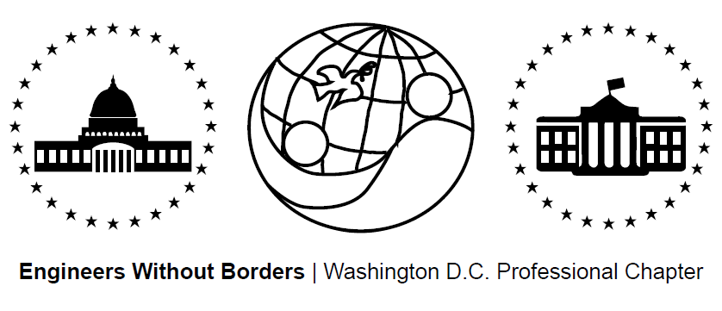
www.ewb-dc.org
General Chapter Meeting – Wednesday, May 20, 2015
George Washington University – Phillips Hall – Room B152
(801 22nd Street, N.W., Washington, DC)

- Introductions and EWB in a Nutshell – Jonathan Mead < president@ewb-dc.org>
- Panama Project Updates – Rahul, Ross, and Jim <panama@ewb-dc.org>
- Team ramping up for trip to Hato Rincon in June for alternative energy tech center
- Additional Panama project update info in the PowerPoint slides from the meeting:
  - Link: https://dl.dropboxusercontent.com/u/16272786/EWB-DC%20May%202015%20Chapter%20Meeting%20Slides.pptx
- Next meeting: Thursday June 4th @ 7:00PM, MLK Library- Digital Commons 2

- El Salvador Project Updates – Julia & Angeline <santaclara@ewb-dc.org>
- Phase II of improved cook stove design – researching / testing / sourcing materials
- Team leaves tomorrow for stove piloting in the community
- Additional El Salvador project update info in the PowerPoint slides from the meeting
  - Link: https://dl.dropboxusercontent.com/u/16272786/EWB-DC%20May%202015%20Chapter%20Meeting%20Slides.pptx
- Next Meeting: June 8th, 2015 @ 6:30PM at MLK Library Digital Commons 2
- Cameroon Project Updates - Rachel & Ashley <cameroon@ewb-dc.org>
- Team of 4 oversaw second phase of gravity water supply system construction in March.
- An 8,600 L storage tank plus additional infrastructure will be built this fall.
- Additional Cameroon project update info in the PowerPoint slides from the meeting
  - Link: https://dl.dropboxusercontent.com/u/16272786/EWB-DC%20May%202015%20Chapter%20Meeting%20Slides.pptx
- Next meeting: Tuesday, May 26th, 2015 @ 7:00PM at George Washington University – Phillips Hall – Room 108
- Cameroon Project January and March 2015 Implementation Trip Presentations
    - January Trip:
      - Constructed Underground Dam
      - Built Spring Box & Drainage
    - March Trip:
      - Built 2 Break-Pressure Tanks
      - Installed Pipeline
      - Constructed Stream Crossing
      - Installed Catchment Barrier

    - Both Trips:
      - Community WASH Promotion & Management Capacity Building
    - See presentation slides from the meeting for lots more details
      - Link: https://dl.dropboxusercontent.com/u/16272786/EWB-DC%20May%202015%20Chapter%20Meeting%20Slides.pptx
- Fundraising Updates:
Panama Team Happy Hour Fundraiser @ City Tap House
- Where: City Tap House (901 I St. NW, Washington, DC)
- When: Friday, May 29th at 6:00pm to 9:00pm
- A $5 wristband gets you two extra hours of happiness
- Enjoy $5 select craft beers and $6 house wine!
2nd Annual DC United Game / Tailgate Fundraiser for the Panama Project
- Where: RFK Stadium When: Sunday, July 26th at 2PM Tailgate, 5PM Game
- Come tailgate at our 3 reserved tents and watch DC United take on Philadelphia
- Tickets: $26 Payment: Venmo @EWBDC-futbol (preferred option) or in cash to Rhiannon Scanlon (Rhiannon.Scanlon@gmail.com)
Amazon.com Fundraising: 6% to EWB-DC! - Link: http://www.amazon.com/?tag=ewbdc-20
- Treasurers Report:
- El Salvador project account balance = $6,968.94
- Panama project account balance = $6,321.09
- Cameroon project account balance = $39,653.15
- Chapter general fund account balance = $4,806.02
- EWB-DC Updates – Ben Hsu <vice_president@ewb-dc.org>
New Website
- www.EWB-DC.org just got a facelift thanks to our amazing IT team!
- A huge thanks to Nathan
- Look forward to a complete revamp of the site
- Blog posters wanted. If interested please email: president@ewb-dc.org
- EWB National / Regional News – Jonathan Mead < president@ewb-dc.org>
Development Engineering Courses / Conferences in Mexico
- Hosted by CATIS-Mexico: http://www.catis-mexico.org/
- “Analysing Earth Friendly Technologies: Studying Context, Culture and Design”
- Dates: July 4 – 18, 2015 and July 25 – August 8, 2015
Technical Papers Available on myEWB-USA
- EWB-USA’s technical papers provide technical guidance to help teams with analysis, design, and construction of projects. Check them out!
- Link: http://my.ewb-usa.org/project-resources/technical-papers
Save the Date: EWB East Coast Professional Conference
- Where: Reston, VA When: July 17 – 19, 2015
Save the Date / Call for Abstracts: EWB Southeast Regional Conference
- Where: Raleigh, NC When: October 2 – 4, 2015
- Presentation abstracts accepted until July 24 by Alex Sander (events@ewb-usa.org)
Join an EWB Technical Advisory Committee
- TACs provide review and guidance for all EWB project designs and are looking for new members (please email president@ewb-dc.org if interested)
Become an EWB Member!
- Get access to a great suite of online technical resources
- Vote / run in chapter elections, travel on project trips, help fund EWB-DC projects
- Local Student Chapter Updates
- Future Chapter Meeting Dates – 7:00pm on the third Wednesday of the month
- June 17th (Wednesday) @ George Washington University – Phillips Building – Room B152
- July 15th (Wednesday) @ George Washington University – Phillips Building – Room 108
- August 19th (Wednesday) @ George Washington University – Phillips Building – Room 108

