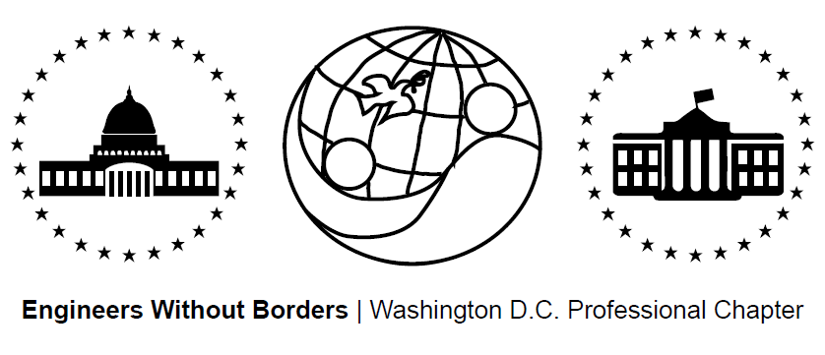
www.ewb-dc.org
General Chapter Meeting – Wednesday, June 17, 2015
George Washington University – Phillips Hall – Room B152
(801 22nd Street, N.W., Washington, DC)

- Introductions and EWB in a Nutshell – Julia Kolberg
- Panama Project Updates – Ross, and Jim <panama@ewb-dc.org>
- Team ramping up for trip to Hato Rincon this month for alternative energy tech center
- Next meeting: Thursday July 2nd @ 7:00PM, MLK Library- Digital Commons 2

- Cameroon Project Updates - Rachel & Ashley <cameroon@ewb-dc.org>
- Second phase of gravity water supply system construction in March.
- An 8,600 L storage tank plus additional infrastructure will be built this fall.
- Next meeting: Tuesday, June 23th, 2015 @ 7:00PM at George Washington University – Duques Hall – Room 359
- El Salvador Project Updates – Julia & Angeline <santaclara@ewb-dc.org>
- Clean burning cook stove pilot completed in May plus water system monitoring
- Next Meeting: June 29th, 2015 @ 6:30PM at MLK Library Digital Commons 2
- El Salvador Project May 2015 Assessment Trip Presentation
- Link to presentation: https://dl.dropboxusercontent.com/u/16272786/Santa%20Clara%20May%202015.pptx
- Fundraising Updates:
2nd Annual DC United Game / Tailgate Fundraiser for the Panama Project
- Where: RFK Stadium When: Sunday, July 26th at 2PM Tailgate, 5PM Game
- Come tailgate at our 3 reserved tents and watch DC United take on Philadelphia
- Tickets: $26 Payment: Venmo @EWBDC-futbol (preferred option) or in cash to Rhiannon Scanlon (Rhiannon.Scanlon@gmail.com)
Amazon.com Fundraising: 6% to EWB-DC! - Link: http://www.amazon.com/?tag=ewbdc-20
- Treasurers Report:
- El Salvador project account balance = $6,968.94
- Panama project account balance = $6,321.09
- Cameroon project account balance = $39,653.15
- Chapter general fund account balance = $4,806.02

- EWB-DC Updates – Julia Kolberg
New Website
- www.EWB-DC.org just got a facelift thanks to our amazing IT team!
- A huge thanks to Nathan
- Blog posters and feedback wanted. Please email: president@ewb-dc.org
- EWB National / Regional News – Julia Kolberg
Development Engineering Courses / Conferences in Mexico
- Hosted by CATIS-Mexico: http://www.catis-mexico.org/
- “Analysing Earth Friendly Technologies: Studying Context, Culture and Design”
- Dates: July 4 – 18, 2015 and July 25 – August 8, 2015
Technical Papers Available on myEWB-USA
- EWB-USA’s technical papers provide technical guidance to help teams with analysis, design, and construction of projects. Check them out!
- Link: http://my.ewb-usa.org/project-resources/technical-papers
EWB East Coast Professional Conference
- Where: Reston, VA When: July 17 – 19, 2015 Limited space. Register now!
- Link: https://www.eventbrite.com/e/ewb-professional-member-workshop-2015-tickets-17172396099
Save the Date / Call for Abstracts: EWB Southeast Regional Conference
- Where: Raleigh, NC When: October 2 – 4, 2015
- Presentation abstracts accepted until July 24 by Alex Sander (events@ewb-usa.org)
Join an EWB Technical Advisory Committee
- TACs provide review and guidance for all EWB project designs and are looking for new members (please email president@ewb-dc.org if interested)
EWB Opens First International Office in Nicaragua
- Opened in collaboration with EOS International, EWB-USA's office in Nicaragua will provide in-country resources and logistical support to chapters and facilitate community and NGO partnerships.
Become an EWB Member!
- Get access to a great suite of online technical resources
- Vote / run in chapter elections, travel on project trips, help fund EWB-DC projects
- Future Chapter Meeting Dates – 7:00pm on the third Wednesday of the month
- July 15th (Wednesday) @ George Washington University – Phillips Building – Room 108
- August 19th (Wednesday) @ George Washington University – Phillips Building – Room 108

