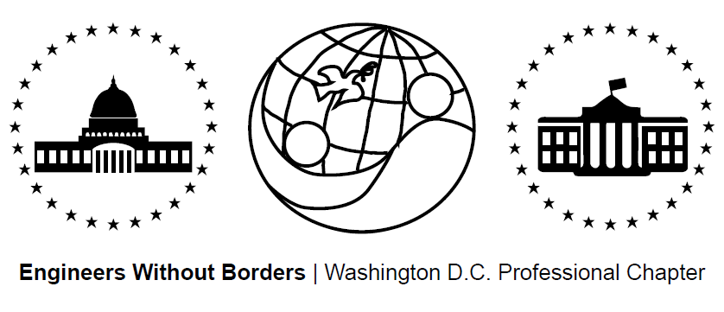
www.ewb-dc.org
General Chapter Meeting – Wednesday, August 19th, 2015
George Washington University – Phillips Hall – Room 108
(801 22nd Street, N.W., Washington, DC)

- Introductions plus an Overview of EWB-USA and the Washington DC Chapter
- Panama Project Presentation & Update – Ross & Jim <panama@ewb-dc.org>
- Team traveled to Hato Rincon in June for alternative energy tech center assessment
- Next meeting: Thursday September 10th @ 7:00PM, location TBA

- Cameroon Project Updates - Rachel & Ashley <cameroon@ewb-dc.org>
- Second phase of gravity water supply system construction completed in March
- An 8,600L storage tank plus additional infrastructure will be built this fall
- Next meetings: September 1st, 15th, & 29th @ 7:00PM at GWU (the team meets every other Tuesday at GWU at 7pm (the building/room varies)
- El Salvador Project Updates – Briana, Eric, Gabe, Heather <santaclara@ewb-dc.org>
- Clean burning cook stove pilot completed in May plus water system monitoring
- Next Meeting: August 24st @ 6:30PM at MLK Library Digital Commons 2 (the team meets every other Monday at the same time and place)
- EWB in a Nutshell
- Fundraising Updates:
Recap: 2nd Annual DC United Game / Tailgate Fundraiser for the Panama Project
Amazon.com Fundraising: 6% to EWB-DC! - Link: http://www.amazon.com/?tag=ewbdc-20
- Treasurers Report:
- El Salvador project account balance = $6,432.32
- Panama project account balance = $5,716.09
- Cameroon project account balance = $55,103.15
- Chapter general fund account balance = $2,149.98
- EWB-DC Updates
Officer Elections
- Chapter officer elections will be held in October. The positions are:
  - President
  - Vice president
  - Treasurer
  - Secretary.
- Please submit nominations to secretary@ewb-dc.org by September 30th, 2015
- EWB National / Regional News
Recap: EWB East Coast Professional Conference
EWB Southeast Regional Conference
- Where: Raleigh, NC When: October 2 – 4, 2015
- Registration: http://ewbusaconference.org/
EWB Fall Project Grants Program
- The grant cycle begins August 24th Deadline: September 17th, 2015
- Link: http://www.ewb-usa.org/grants/ All eligible projects should apply!
New EWB-USA Help Center (http://help.ewb-usa.org/)
- EWB-USA's new Help Center has a wealth of information on EWB-USA programs, project process and available resources
- Search by keyword or browse by topic to instantly find answers to your questions
Technical Papers Available on myEWB-USA
- EWB-USA’s technical papers provide technical guidance to help teams with analysis, design, and construction of projects. Check them out!
- Link: http://my.ewb-usa.org/project-resources/technical-papers
Become an EWB Member!
- Get access to a great suite of online technical resources
- Vote / run in chapter elections, travel on project trips, help fund EWB-DC projects
- Next Chapter Meeting Info – (Meetings are at 7:00pm on the third Wednesday of the month)
- September 16th (Wednesday) @ George Washington University – Building and Room TBD

