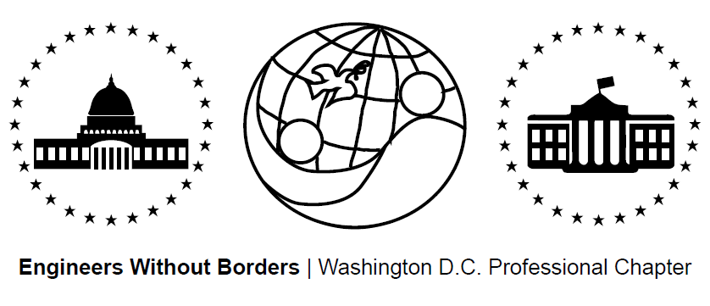
www.ewb-dc.org
General Chapter Meeting – Wednesday, July 15, 2015
George Washington University – Phillips Hall – Room 108
(801 22nd Street, N.W., Washington, DC)

- Introductions plus an Overview of EWB-USA and the Washington DC Chapter
- Panama Project Updates – Ross & Jim <panama@ewb-dc.org>
- Team traveled to Hato Rincon in June for alternative energy tech center assessment
- Next meetings: Thursdays July 16th & 30th @ 7:00PM, MLK Library Chinatown
(the Panama team meets every other Thursday at the same time and place)

- Cameroon Project Updates - Rachel & Ashley <cameroon@ewb-dc.org>
- Second phase of gravity water supply system construction completed in March
- An 8,600L storage tank plus additional infrastructure will be built this fall
- Next meetings: July 21st & August 7th @ 7:00PM at GWU, Duques Hall, Room 359 (the team meets every other Tuesday at GWU at 7pm (the building/room varies)
- El Salvador Project Updates – Briana, Julia, & Angeline <santaclara@ewb-dc.org>
- Clean burning cook stove pilot completed in May plus water system monitoring
- Next Meeting: July 27, 2015 @ 6:30PM at MLK Library Digital Commons 2
(the El Salvador team meets every other Monday at the same time and place)
- Fundraising Updates:
2nd Annual DC United Game / Tailgate Fundraiser for the Panama Project
- Where: RFK Stadium When: Sunday, July 26th at 2PM Tailgate, 5PM Game
- Come tailgate at our 3 reserved tents and watch DC United take on Philadelphia
- Tickets: $26 Payment: Venmo @EWBDC-futbol (preferred option) or in cash to Rhiannon Scanlon (Rhiannon.Scanlon@gmail.com)
Amazon.com Fundraising: 6% to EWB-DC! - Link: http://www.amazon.com/?tag=ewbdc-20
- Treasurers Report:
- El Salvador project account balance = $6,968.94
- Panama project account balance = $6,321.09
- Cameroon project account balance = $39,653.15
- Chapter general fund account balance = $4,806.02
- EWB-DC Updates
New Website
- www.EWB-DC.org just got a facelift thanks to our amazing IT team!
- Blog posters and feedback wanted. Please email: president@ewb-dc.org
Officer Elections
- Chapter officer elections will be held in October. The positions are:
  - President
  - Vice president
  - Treasurer
  - Secretary.
- Please submit nominations to president@ewb-dc.org by September 30th, 2015
- EWB National / Regional News
EWB East Coast Professional Conference
- Where: Reston, VA When: July 17 – 19, 2015 Register now!
- Link: https://www.eventbrite.com/e/ewb-professional-member-workshop-2015-tickets-17172396099
EWB Southeast Regional Conference
- Where: Raleigh, NC When: October 2 – 4, 2015
- Registration: http://ewbusaconference.org/
- Presentation abstracts accepted until July 24 by Alex Sander (events@ewb-usa.org)
- Poster application form: http://tinyurl.com/olerbez
EWB-Northern Virginia Seeks Domestic Project Independent Reviewers
- EWB-NOVA has two positions open on their Independent Review Committee for their Cedar Gulch, SD community center construction project
- The role includes review of all project assessment, alternatives analysis, design, implementation, and monitoring reports
- If interested, please email Janet Chang (jjchang@bechtel.com) & Jon Mulligan (jon.p.mulligan@gmail.com)
New EWB-USA Help Center (http://help.ewb-usa.org/)
- EWB-USA's new Help Center has a wealth of information on EWB-USA programs, project process and available resources
- Search by keyword or browse by topic to instantly find answers to your questions
Improving EWB-USA’s Project Process
- EWB-USA is reviewing the project process to enable members to work more effectively and efficiently with community partners. This process will be ongoing and every summer, EWB-USA project staff will review feedback and suggestions.
- Respond by July 24 for your feedback to be included in this summer's discussion.
- Link: http://tinyurl.com/q3ksryo
Technical Papers Available on myEWB-USA
- EWB-USA’s technical papers provide technical guidance to help teams with analysis, design, and construction of projects. Check them out!
- Link: http://my.ewb-usa.org/project-resources/technical-papers
Become an EWB Member!
- Get access to a great suite of online technical resources
- Vote / run in chapter elections, travel on project trips, help fund EWB-DC projects
- Next Chapter Meeting Info – (Meetings are at 7:00pm on the third Wednesday of the month)
- August 19th (Wednesday) @ George Washington University – Phillips Building – Room 108

